Ian McPherson

Compiled and loaded statements.

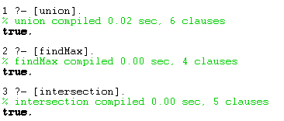

Capture.PNG

Capture.PNG

Union

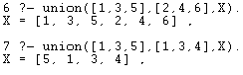

findMax

Capture.PNG

intersection

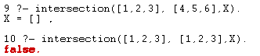

sister

Capture.PNG

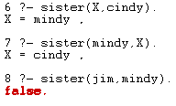

quicksort

Capture.PNG